Varendra University



Department of Computer Science and Engineering

Assignment

Course code: CSE 2201
Course Title: Software Engineering and System Analysis
Submission Date : 5th November, 2025
Name : Mst Soniya Akter
Student ID : 241311050
Section : B
Semester : 4th Semester
Batch : 34th
Submitted By
Submitted To
Name : Mohammad Faisal Al-Naser
Designation : Lecturer

“Amar Dokan – The Business Media Platform”

Software Project Management Plan
Project Title: “Amar Dokan – The Business Media Platform”

1. Project Initiation
1.1 Project Scope
Amar Dokan is a versatile business media platform for connectivity between customer, entrepreneurs, and businesses in Bangladesh. The platform addresses several challenges for e-commerce; weak business planning, inventory issues and lack of market linkages. The platform connects suppliers, whole-sellers and retailers to provide improved supply chain, stock management and demand planning capabilities. Some other important function of the platform are ERP, product shifting tools and consignment sales to facilitate business functions and to reduce failure of businesses. Amar Dokan is intended to provide a enabling ecosystem for the growth and sustainability of entrepreneurs and contribute to the digitization of business in Bangladesh.
Key Features
- Social media like business interaction platform
- Connects wholesalers, retailers, and customers
- Inventory and ERP integration
- Consignment sales and product shifting options
- Nearest shop finder and advertisement system
Main Objectives
- Reduce the high failure rate of online businesses.
- Improve supply chain stability between sellers and customers.
- Build a communication bridge between entrepreneurs and companies.

1.2 Stakeholders and Their Roles
Stakeholder | Role/Responsibility
Entrepreneurs / Sellers | Use the platform to promote and sell products.
Customers | Buy and review products.
Admin | Manage users, handle payments, and monitor system activity.
Developers | Build and maintain the platform.
Investors | Provide funding for development and scaling.
Project Manager | Ensure all phases are completed on time and within budget.

1.3 Project Charter
Objective | To develop a business platform that connects buyers, sellers, and companies, solving the e-commerce failure issue.
Assumptions | Internet availability, smartphone access, and business interest from users.
Constraints | Limited fund (1.12M BDT), limited manpower, large data management.
Success Criteria | Successful integration of users, positive growth in active sellers, and stable system performance.

2. Project Planning
2.1 Work Breakdown Structure (WBS)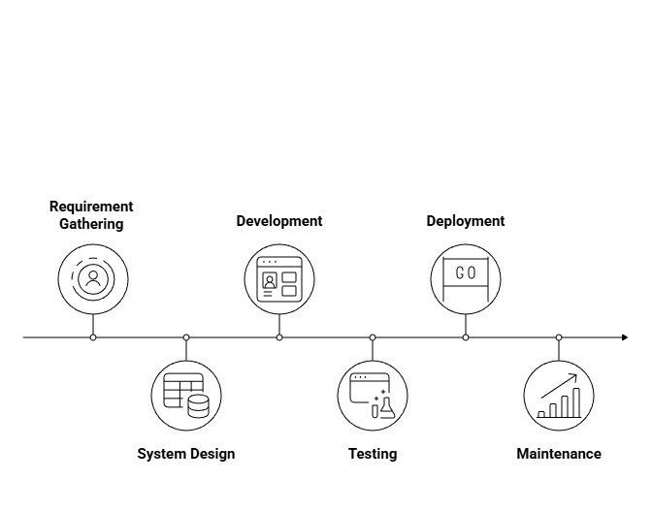
Figure 01: Work Breakdown Structure Map

- Requirement Gathering
  - Identify user needs (customers, sellers, companies)
  - Define system modules
- System Design
  - Database and UI design
  - API design for connection between modules
- Development
  - Frontend (web + app)
  - Backend (server, database, API)
- Testing
  - Unit testing and integration testing
- Deployment
  - Hosting and launching Amar Dokan platform
- Maintenance
  - Regular updates and bug fixes

2.2 Project Schedule (Gantt Chart Summary)
Task | Duration | Start | End
Requirement Analysis | 2 weeks | Week 1 | Week 2
System Design | 2 weeks | Week 3 | Week 4
Development | 5 weeks | Week 5 | Week 9
Testing | 1 week | Week 10 | Week 11
Deployment | 1 week | Week 12 | Week 12
Maintenance | Continuous After launch

2.3 Budget Estimation
Item | Cost (BDT)
Developer Salaries | 500,000
Server and Hosting | 120,000
Design & Tools | 80,000
Marketing | 200,000
Maintenance | 100,000
Total | 1,120,000 (1.12M)

3. Team Formation
Role | Responsibilities
Project Manager | Oversees the entire project, managing timelines, budget, and risk assessments. Ensures that project objectives are met on time and within the allocated budget.
System Analyst | Responsible for gathering and analyzing requirements, creating system designs, and documenting user flows. This person ensures that the platform meets user needs.
Frontend Developer | Develops the user-facing components of the platform, ensuring a smooth, interactive user experience.
Backend Developer | Manages the server-side logic, database design, and integration. Ensures that the platform functions seamlessly and handles all backend processes efficiently.
UI/UX Designer | Designs the platform’s interface and experience, focusing on creating an intuitive, user-friendly design.
QA Tester | Responsible for testing the platform for bugs, issues, and performance, ensuring that it meets quality standards before launch.
System Administrator | Ensures the system’s functionality post-launch by managing security, data backups, and maintaining the platform’s overall health.

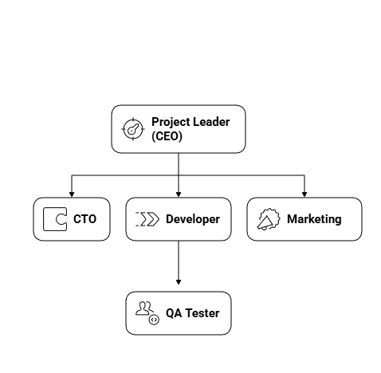
Organizational Chart

4. Risk Management
4.1 Possible Risks
Risk | Likelihood | Impact
Lack of skilled manpower | Medium | High
Fund shortage | High | High
Server downtime | Low | Medium
Data breach or cyberattack | Low | High
Market competition | High | Medium
4.2 Mitigation Plan
Risk | Mitigation Strategy
Skilled manpower | Provide training and internships
Fund shortage | Seek investors and partnerships
Server issues | Use cloud backup and monitoring
Data breach | Apply SSL and encryption
Competition | Offer unique features and user support

5. Development
5.1 Methodology Used
Agile Development Methodology
Justification:
- Amar Dokan is a large platform that needs flexibility and feedback from users.
- Agile allows short, iterative development cycles (sprints).
- Each sprint focuses on improving specific features (ERP, nearest shop, dynamic web builder).
5.2 Sprint Breakdown
Sprint | Main Focus | Duration
Sprint 1 | Requirement & Design | 2 weeks
Sprint 2 | Core Development | 3 weeks
Sprint 3 | Testing & Integration | 2 weeks
Sprint 4 | Deployment & Feedback | 1 week

6. Conclusion
Amar Dokan is a fast-paced, business-centric social platform designed to empower entrepreneurs by facilitating interaction between customers and suppliers, bundled in one comprehensive digital platform. Based on the established work style of the Agile methodology, this is a platform that values flexibility, risk management, and true project planning in order to lessen the high startup failure rate and support sustainable business growth in Bangladesh. Each step in this project is structured and rationalized through achievable targets, from project initiation through execution and deployment. At the center of this platform is its core mission and motto: "The power of connection, the future of business."

